2020 Grower Membership Support Packages
AUSVEG SA is the state-wide representative body for South Australia's $700 million vegetable industry. We work with governments of all levels to advocate on key issues and deliver a number of key industry development programs which support the hardworking growers of our state to reach their potential.
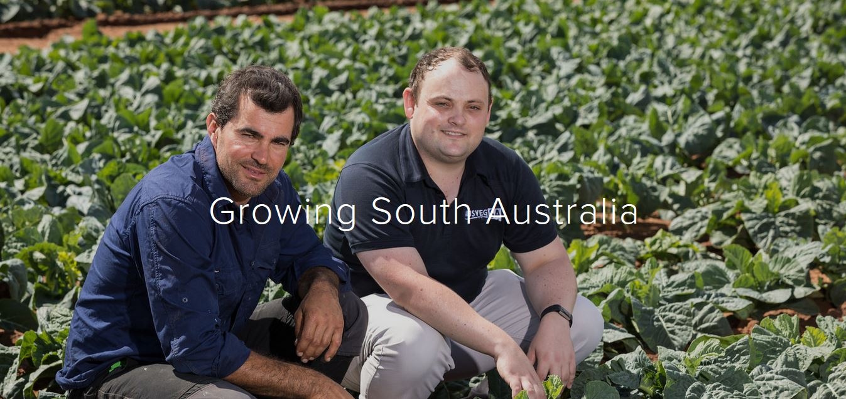

A strong voice for South Australian growers

AUSVEG SA works to improve the lives of the hardworking growers of this state.
AUSVEG SA was established in 2014 to be a strong and unified association for South Australian Growers.
Since establishment AUSVEG SA has grown to be a strong and respected voice within South Australia advocating with governments of all levels to improve the livelihoods of local growers and grow the industry. We are well respected by all sides of politics for out track record of working constructively to deliver outcomes for industry.

Key achievements include:
- Advocating for local growers to achieve equitable access to the $150 million Northern Adelaide Irrigation Scheme and continued work to ensure an economically-viable pricing structure for industry.
- Successfully fighting a proposed increase to the NRM levy which would have cost growers an additional $2,000 per annum to commercial water costs.
- Successfully fighting a proposed Playford Council rate increase in 2017 which would have cost a large number of growers in the state from $30,000 to $70,000 in additional rates and hampered jobs growth.
- Standing up for industry interests with governments, supply chain and the unions on key issues such as labour, competition policy and planning reform.
- Assistance with disaster recovery for growers and members after floods and bushfire incidents.
- Working with governments of all levels to set an agenda which progresses the needs of vegetable and horticultural businesses in the state.

What we do
AUSVEG SA strives to continue our strong track record as a respected and strong voice for South Australia’s $700 million vegetable sector. We work with governments of all levels to push for policy reform to support our industry as well as advocacy for individual growers to assist with issues at the farm level.
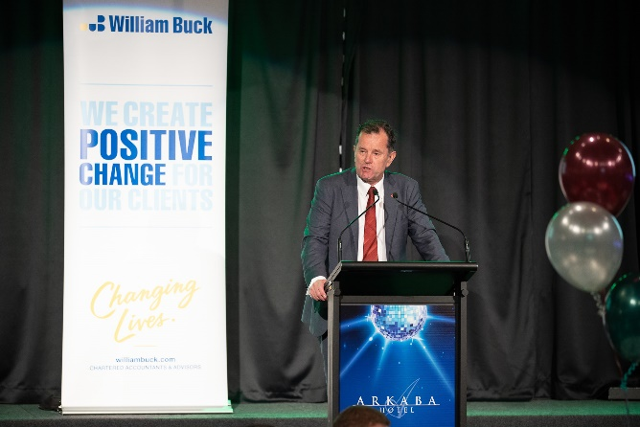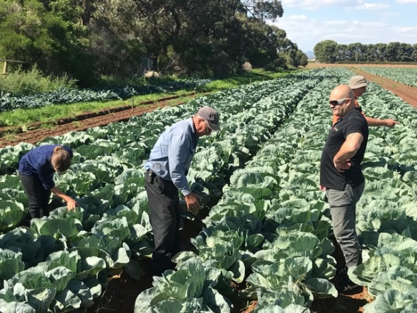
In addition to our advocacy we are committed to rolling out a number of key R&D and business programs as an opportunity for growers to access business opportunities and deal with regional production issues.
Advocacy for industry | Delivering key programmes
At AUSVEG SA we strive to improve the lives of South Australia's hardworking growers. We welcome anyone to join us, no matter their role in horticulture and work everyday to ensure that government and the broader public appreciate the $1.5 billion contribution that South Australian horticulture growers make in feeding our great nation.  Since establishment AUSVEG SA has grown to be a strong and respected voice within South Australia advocating with governments of all levels to improve the livelihoods of local growers and grow the industry.  Some of our activities include  - Working with governments of all levels on issues such as visa reform, biosecurity management, access to infrastructure, planning issues and working with national bodies on cross jurisdictional issues to drive results for growers.  - Assisting members at the business level to deal with regional issues such as union disputes, planning conflicts, access to relevant R&D to solve production issues among other things.  AUSVEG SA is well respected within government and has a strong track record of advocating for positive change for industry. | AUSVEG SA runs a number of industry development programs aimed at building capacity and R&D knowledge in our sector. We regularly run programs for our members with funding from a variety of sources to ensure that our growers have access to the knowledge and support to grow their businesses.  These include:  - A dedicated export facilitation service for growers providing support on accessing key markets and market opportunities through national export initiatives.  - An R&D extension service and workshops which provide targeted workshops and researcher engagement to deal with regional production issues such as salinity, biosecurity practice change and soil health.  - Delivery of the Clean Your Farm initiative to support growers to implement practices on farm as a protection against incursions.  - An advanced LEAN manufacturing and automation project which has assisted growers to identify millions in efficiencies on-farm.

Grower Membership Support Packages
AUSVEG SA has grown significantly since inception and now the vegetable industry has the backing of one of the largest and most influential industry associations in South Australian agriculture. AUSVEG SA will continue to work with governments of all levels to secure ongoing investment and policy reforms which assist our growers in a challenging operating environment.
While AUSVEG SA has offered free membership since inception and will continue to do so, we have introduced membership support packages in line with other industry associations to build resilience in our service delivery model.
AUSVEG SA remains one of the strongest and most financially viable groups in South Australian agricultural advocacy, however, membership contributions will assist our association to continue to grow the services and advocacy we are able to do for growers in the state and help us fund key advocacy campaigns and activities as they arise.
AUSVEG SA at present do not receive any organisational funding from growers or through the levies that growers pay. We rely solely on corporate and government fee for service. Due to the lack of continuity of some traditional sources of funding, for us to maintain our services to growers we will need to introduce a structured voluntary paid membership fee to ensure we can maintain our current level of support for industry. This funding will directly contribute to a strong advocacy voice for industry.
AUSVEG SA membership is also tax deductible provided it is directly relevant to member businesses or individuals.

Membership categories
AUSVEG SA has structured voluntary membership categories based on the size of the business and included a number of additional benefits for paying members listed below.
Membership Category | Membership benefits
Grower Support Package (Indicative range of less than $1  million turnover pa)  $350 plus GST pa | In addition to making a contribution towards the ongoing strength of AUSVEG SA as a leading advocate for industry and contributing to our campaigns, small grower supporters will receive:  - Business level advocacy and support as required such as advice with dealing with government departments and dealing with business level issues.  - Advocacy and support accessing key government and industry programmes  - Key industry notifications of key events and issues  - One ticket to the 2020 AUSVEG SA Vegetable Industry Awards for Excellence and Hort Conference and one ticket to the AUSVEG SA End of Year Drinks  - Membership of AUSVEG SA is tax-deductible (please check with your relevant tax advisor to discuss specific circumstances)
Grower Support Package (Indicative range of less than $5 million turnover pa)  $550 plus GST pa | In addition to making a contribution towards the ongoing strength of AUSVEG SA as a leading advocate for industry and contributing to our campaigns, small grower supporters will receive:  - Business level advocacy and support as required such as advice with dealing with government departments and dealing with business level issues.  - Advocacy and support accessing key government and industry programmes  - Key industry notifications of key events and issues  - One ticket to the 2020 AUSVEG SA Vegetable Industry Awards for Excellence and Hort Conference and one ticket to the AUSVEG SA End of Year Drinks  - Membership of AUSVEG SA is tax-deductible (please check with your relevant tax advisor to discuss specific circumstances)
Larger grower Support Package (Indicative range of $5 million plus turnover pa)  $1,000 plus GST pa | In addition to making a contribution towards the ongoing strength of AUSVEG SA as a leading advocate for industry and contributing to our campaigns, small grower supporters will receive:  - Business level advocacy and support as required such as advice with dealing with government departments and dealing with business level issues.  - Advocacy and support accessing key government and industry programmes  - Key industry notifications of key events and issues  - One ticket to the 2020 AUSVEG SA Vegetable Industry Awards for Excellence and Hort Conference and one ticket to the AUSVEG SA End of Year Drinks  - Acknowledgement as a key industry supporter on the AUSVEG SA website and AUSVEG SA Vegetable Industry Dinner.  - Membership of AUSVEG SA is tax-deductible (please check with your relevant tax advisor to discuss specific circumstances)
Horticulture Leaders Business Group  $3,000 plus GST pa | - Participation in bi-annual Horticulture Leaders Business Forum  - Work with AUSVEG SA and other industry leaders to proactively set an agenda for horticultural business growth in the state  - Business level advocacy and support as required such as advice with dealing with government departments and dealing with business level issues.  - Advocacy and support accessing key government and industry programmes  - Acknowledgement as a key industry supporter on AUSVEG SA website, newsletter and at the 2020 Vegetable Industry Dinner and Conference.  - Two tickets to the 2020 AUSVEG SA Vegetable Industry Awards for Excellence and Hort Conference and two tickets to the AUSVEG SA End of Year Drinks  - Membership of AUSVEG SA is tax-deductible (please check with your relevant tax advisor to discuss specific circumstances)

The Final Word
AUSVEG SA thanks the many growers of the state for their support since inception. As an association we will continue to strive to be a leading advocacy body in South Australia and improve the outlook for horticulture in South Australia.
As CEO I am committed to working with the families and businesses of each of our members and thank the growers for their support to-date.
I hope that growers will consider becoming Grower Supporters of our association, which will greatly assist AUSVEG SA to grow into the future and continue to serve industry.
As always, growers can contact me any time to discuss their priorities and the pressing issues facing our sector.
Thank you for your support,

Jordan Brooke-Barnett
Chief Executive Officer

ABN: 58 601 467 583 www.ausvegsa.com.au
AUSVEG SA, South Australian Produce Market, Burma Road Pooraka SA 5095
I M: 0404 772 308I E: jordan.brooke-barnett@ausveg.com.au

